Retail Sales Analysis - SQL Project

Introduction
- This project uses SQL to perform a comprehensive analysis of a retail store's transactional data. By leveraging a structured database containing customer demographics, product categories, sales, and cost information, we extract actionable business insights.
- The goal is to move beyond simple data retrieval and demonstrate how SQL can uncover patterns in sales trends, customer behavior, and product performance.

Project Objective
The primary objective of this project is to analyze the provided retail sales data to answer key business questions and guide strategic decisions.
Specifically, the project aims to:
- Understand Sales Trends: Calculate total revenue, identify top-selling categories, and analyze sales by month and year to understand what drives the business.
- Gain Customer Insights: Identify the most valuable customers, understand their purchasing habits, and segment them by gender and age.
- Evaluate Category Performance: Determine which categories are most profitable, which have the highest number of transactions, and which may be underperforming.
- Demonstrate SQL Proficiency: Use SQL commands like GROUP BY, ORDER BY, aggregate functions (SUM, AVG, COUNT), and subqueries to solve complex business problems.

Analysis Questions

- Sales & Revenue Analysis
- What is the total sales amount across all transactions?
- How many transactions have been recorded in total?
- What are the monthly sales totals for the years 2024 and 2025?
- What is the total sales amount for the Electronics category in 2025?
- What is the total sales amount from custom over 50 years old?
2.Customer Insights
- What is the average age of customers broken down by gender?
- Who are the top 5 customers ranked by their total spending?
- How many unique customers have made purchases?
3. Category & Product Performance
- How do sales break down by product category, including total sales and the number of transactions per category?
- Which product category is the most popular based on the highest number of transactions?
- What is the total profit per category (calculated as total sales minus cost of goods sold)?
4. Operational Metrics
- What is the average number of items sold per transaction?
- What is the average sales amount per day?
- What is the total sales amount segmented by customer gender?
These questions directly align with the queries already written in the SQL file you uploaded.
Click here to get the Product Data Set 🔗
Click here to get the Customer Data Set 🔗
Click here to get the Sales Data Set 🔗

Table Description
This database contains a three main table named Product, Customer, Sales:
Product: This table stores details of each product transaction including the transaction ID, product category and cost of goods sold (COGS). It forms the base for linking product information with sales records.
Customer: This table contains information about customers such as their unique customer ID, gender and age. It is used to analyse customer demographics and buying behaviour.
Sales: In this records each sales transaction with quantity, date, time, price per unit and total sale value. It links products to customers, enabling sales trend and performance analysis.

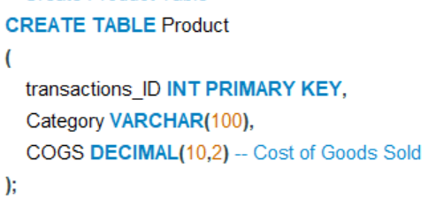

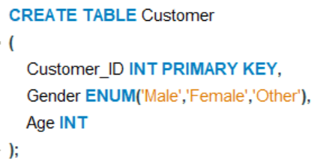

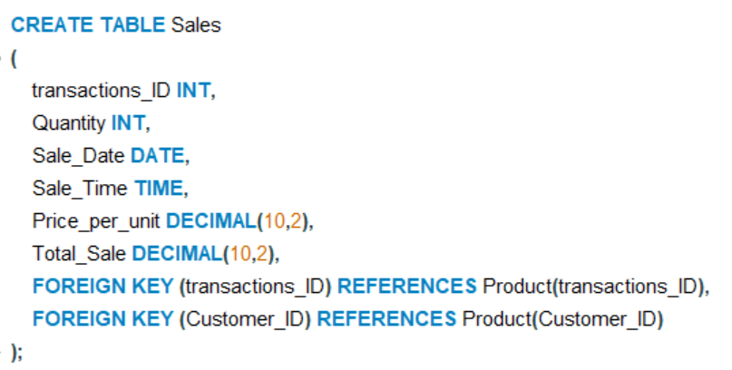

This table is populated with transactional data from 2024 and 2025 and forms the basis for all analysis queries.

ER DIAGRAM

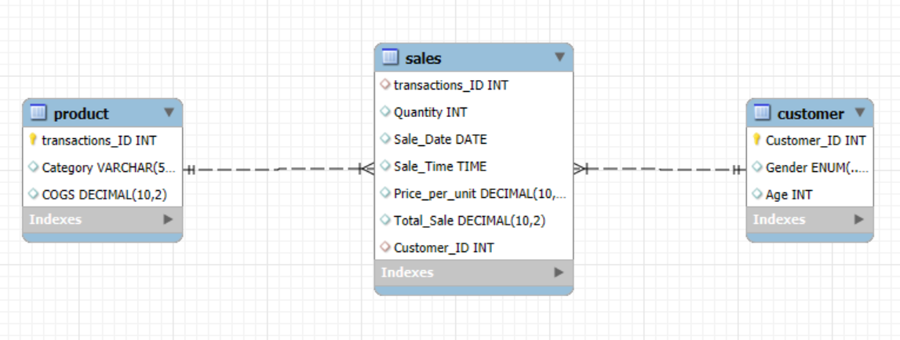

Future Scope
This Retail Sales Analysis project demonstrates how SQL can be used to
- Track total sales, profits, and customer demographics.
- Identify top-performing product categories and high-value customers
- Discover monthly/seasonal trends and improve decision-making
The insights gained can inform marketing strategies, inventory management, and pricing decisions. Future enhancements could include connecting the SQL results to BI tools like Tableau or Power Bi to create interactive dashboards

